

Software Requirements Specification

IBS-001

19 February 2026

Table of Contents
1. Introduction 6
2. Inputs 6
3. Overview 7
4. User Interface Design 8
5. Data Element 10
6. Business Rules 11
8. Dropdown Tables 14

APPROVALS
The specifications document is created and approved for the specifications to be uniformly acknowledged and applied within the Corporation.

The signatures of the people below indicate an understanding in the purpose and content of this document by those signing it. By signing this document, you indicate that you approve of the specifications outlined in this document.

Name | Designation | Signature | Date

DOCUMENT CONTROL
Sponsor | RTIS
Project Lead
Title
Created By | Ntandoyenkosi Gumede
Creation Date | 2026-02-19

DOCUMENT HISTORY
Amended by | Summary of Changes | Version | Date
Ntandoyenkosi Gumede | Specification compilation | Draft | 2025-08-23

Introduction
  - Purpose
The purpose of this transaction is to allow new customers to self-register on the Intelligent Bank System (IBS).
The system ensures that only valid and verified customers are allowed to create banking accounts.

  - Scope

The Registration module allows a customer to:

- Capture personal information
- Create login credentials
- Verify email via OTP
- Accept terms and conditions
- Successfully create a customer profile

  - Definition, Acronyms, and Abbreviations

  - References

  - Technologies to be used
- FRONTEND: JSP
- BACKEND: springbot
- DATABASE: PostgreSQL

Inputs
Business specifications containing:
- Screen prototypes
- Business rules
- Database select statements
- Database updates
- ERD
- Class Diagram
- Activity Diagram
- Use Case

Overview
The Registration module allows a new customer to create an online banking profile by entering personal details and secure login credentials.
The system validates captured data, checks for duplicate records, enforces password security rules, and sends an OTP to verify email before activating the account

User Interface Design
4.1 Sign Up Page

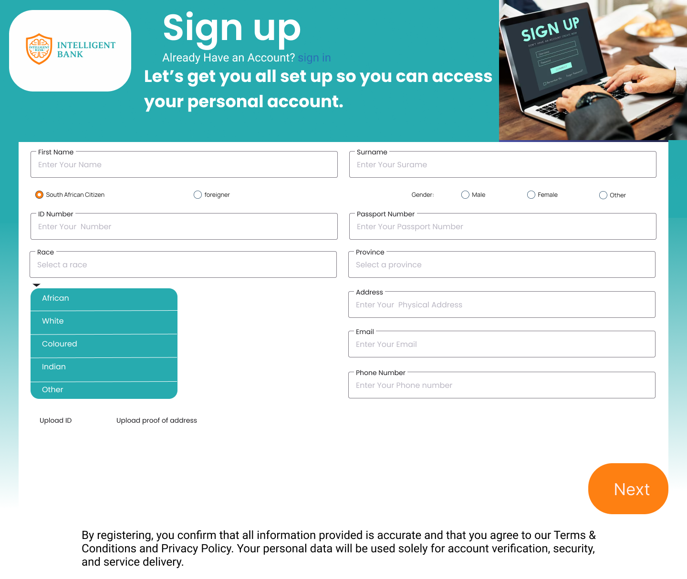

  - Data Elements

Data Element

Input Field Name | Description | Data Type/ Size | Mandatory | Lookup | Object Attribute

Business Rules

Title | Field Name | BR# | BR Description | Error Message

  - User Stories
Title | Field Name | US# | BR Description | Error Message

  - UML Diagrams

Dropdown Tables

Dropdown Code | Description
01

  - Rest APIs

